**Name: SHAMJAD MAZOOD NAZER**

**Roll No: 36**

**Batch: R-MCA B**

**Date: 21/03/2022**

**NETWORKING & SYSTEM ADMINISTRATION LAB**

**Experiment No.: 1**

**Aim**

Install the latest version of Ubuntu on an Oracle VM VirtualBox.

**Procedure**

1. Installing Virtual Box.
   1. Starting pop-up window for the installation.

**Output Screenshot**

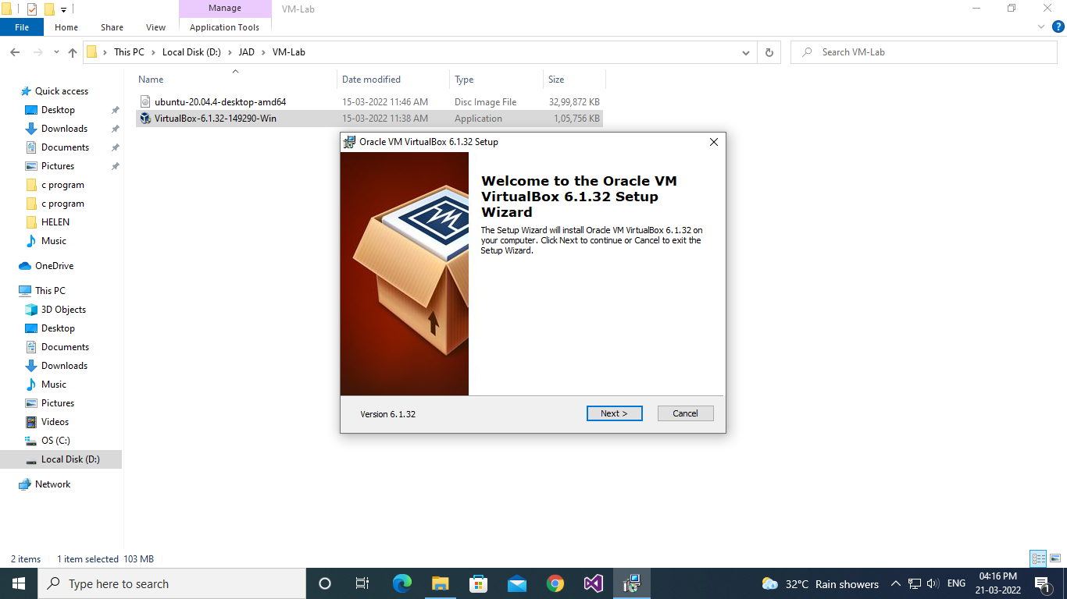

**Procedure**

* 1. Custom setup window to select the features you want and select installation location.

**Output Screenshot**

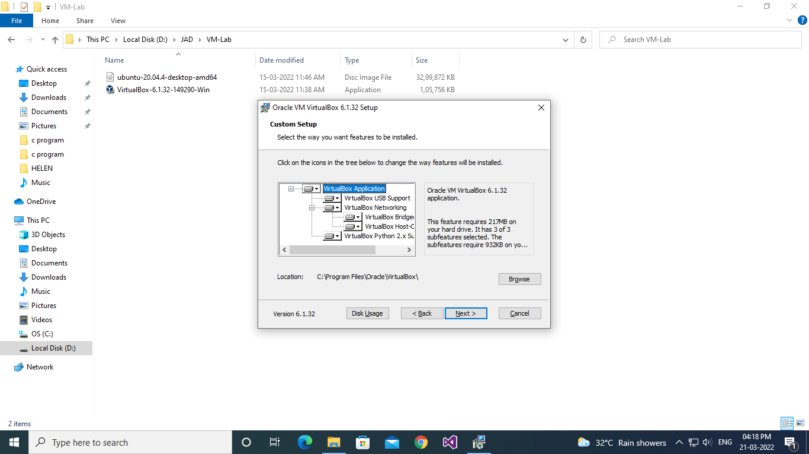

**Procedure**

* 1. Custom setup window to choose from the option below.

**Output Screenshot**

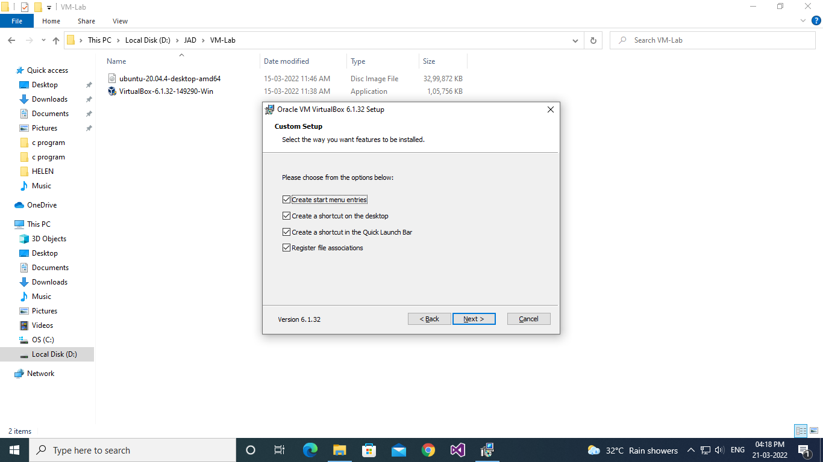

**Procedure**

* 1. Custom setup window to confirm the installation.

**Output Screenshot**

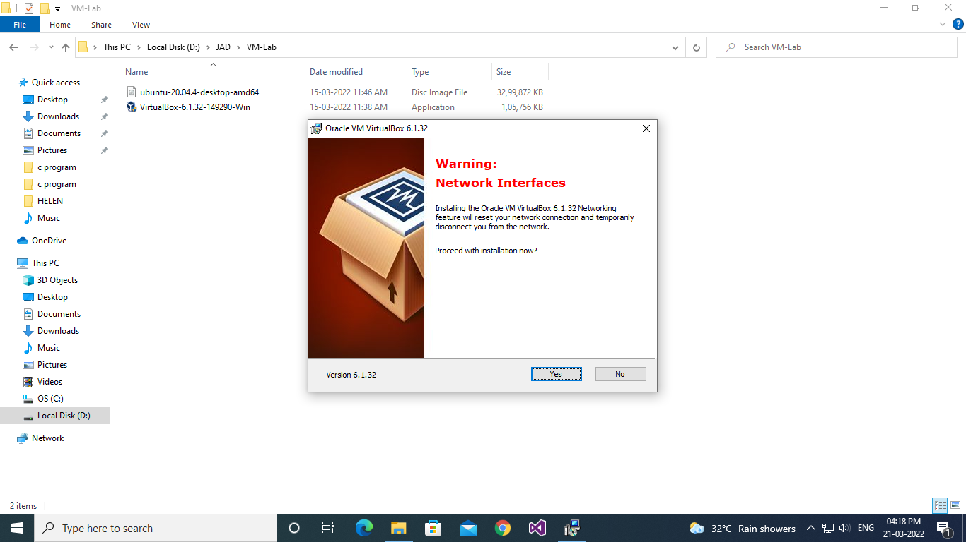

**Procedure**

* 1. Custom setup window to install the virtual box with the install button.

**Output Screenshot**

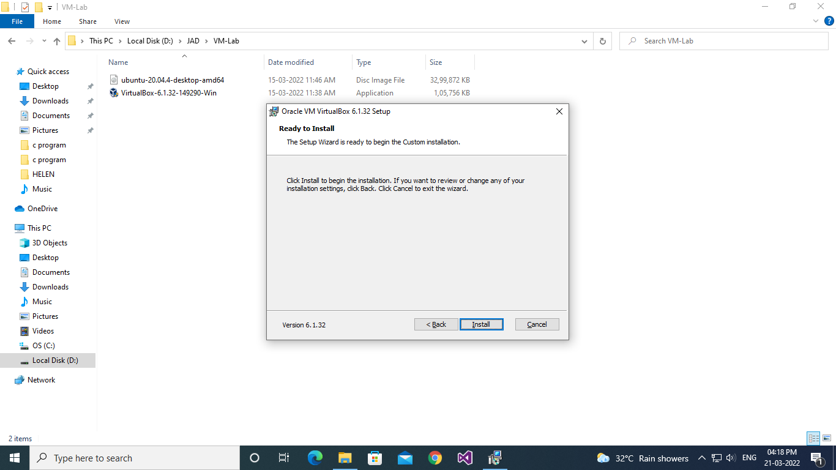

**Procedure**

* 1. Installation box showing the installation status.

**Output Screenshot**

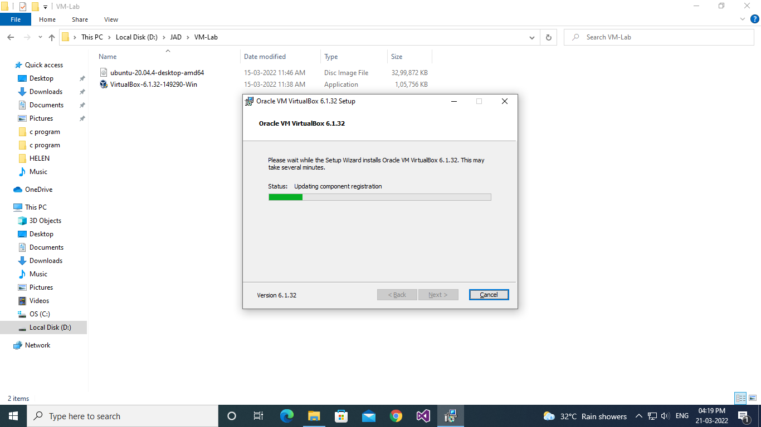

**Procedure**

* 1. Installation complete pop-up windows with the finish button.

**Output Screenshot**

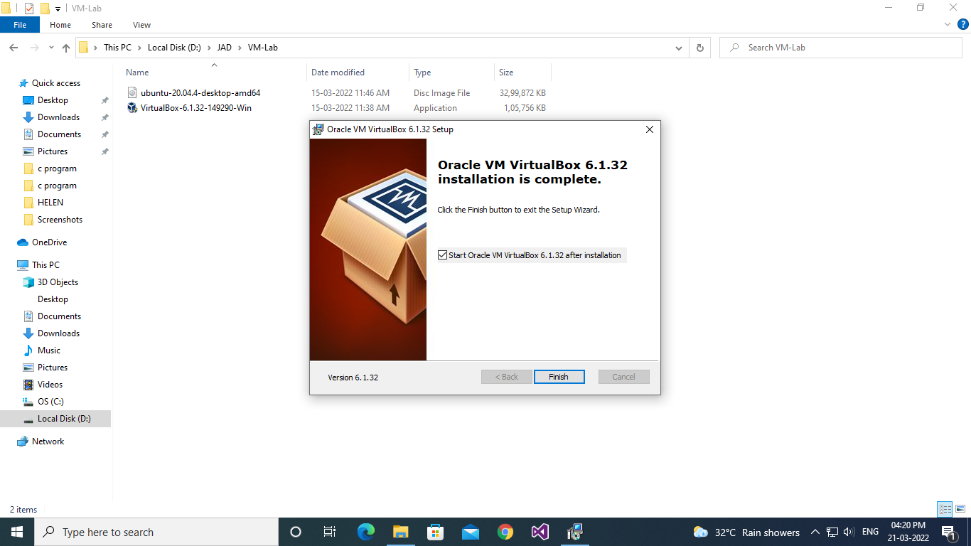

**Procedure**

1. Setup the Ubuntu Instance in the VM Virtual Box.

**Output Screenshot**

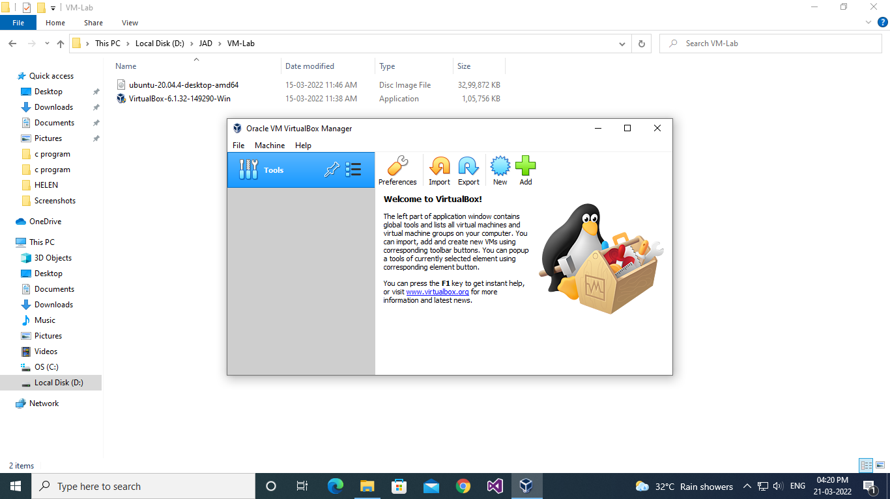

**Procedure**

* 1. After selecting the NEW button to create the Ubuntu instance, the pop-up window to enter & select the name, type and version of the OS.

**Output Screenshot**

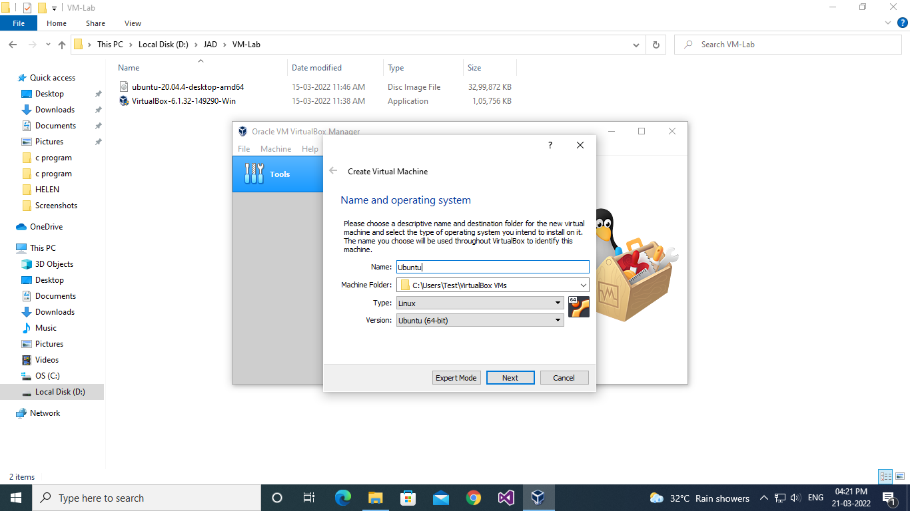

**Procedure**

* 1. Choose the main memory size for the OS.

**Output Screenshot**

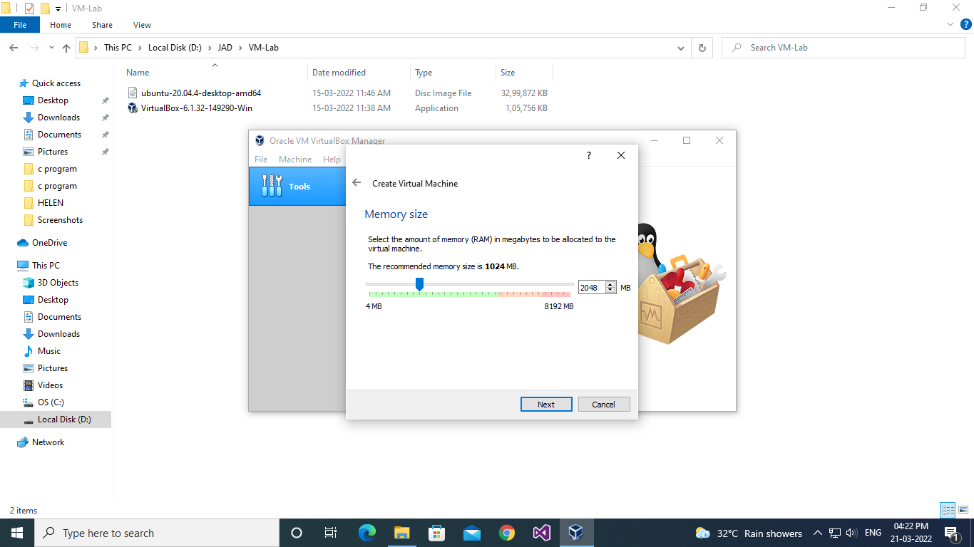

**Procedure**

* 1. Option to add a virtual hard disk to the new machine instance.

**Output Screenshot**

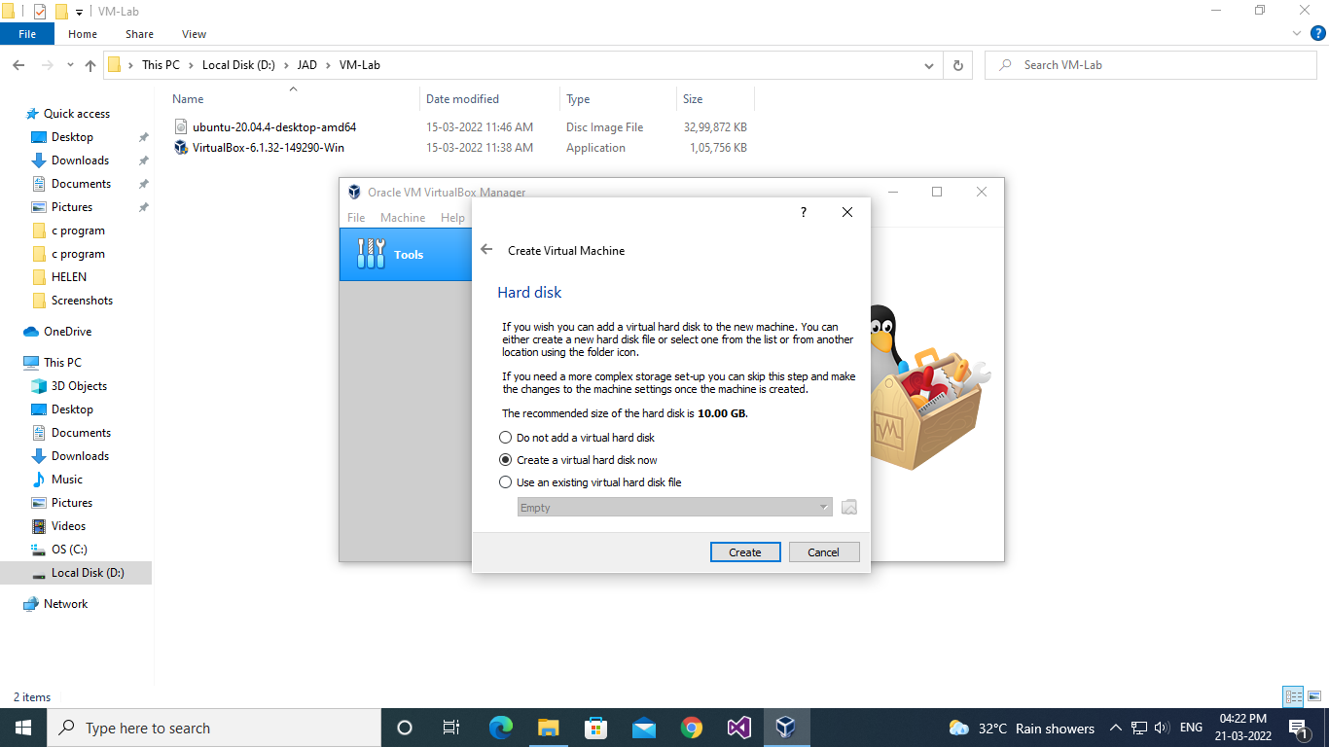

**Procedure**

* 1. Option to choose the type of new virtual hard disk for new instance of OS.

**Output Screenshot**

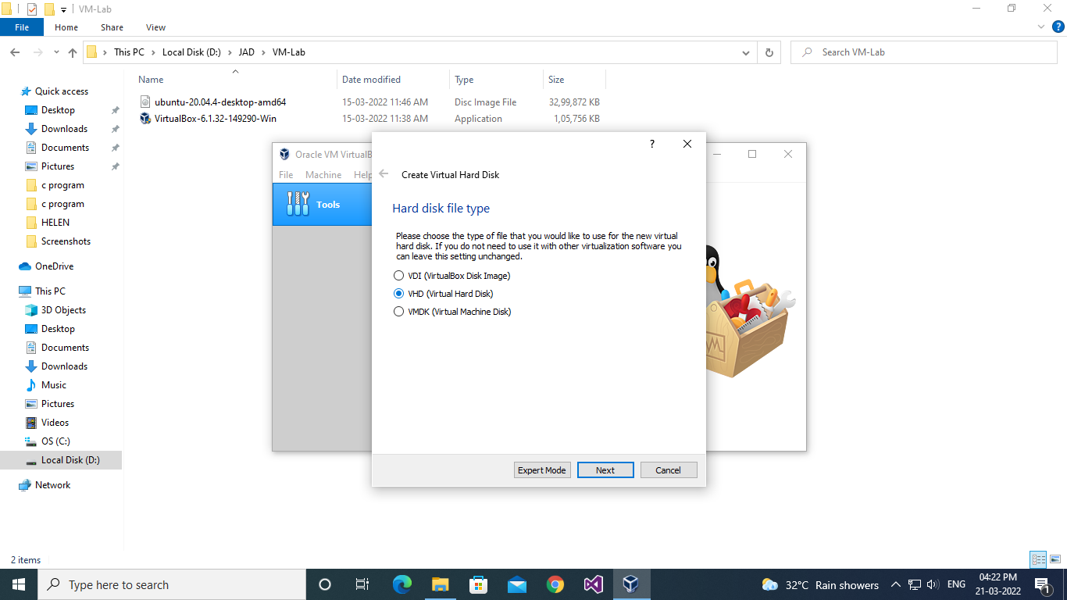

**Procedure**

* 1. Options to choose the methods of accessing the physical hard disk space for the new instance from the existing hard disk.

**Output Screenshot**

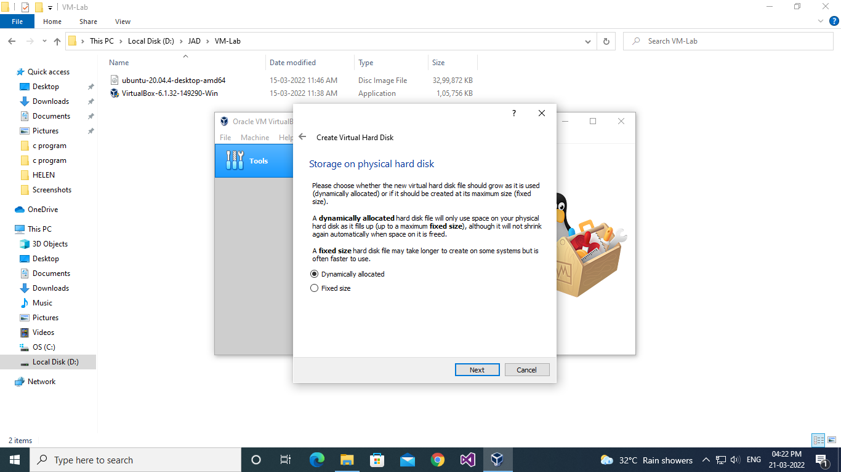

**Procedure**

* 1. Panel to select the size of the virtual disk in megabytes and location and name of the instance and final submit to create the instance of OS.

**Output Screenshot**

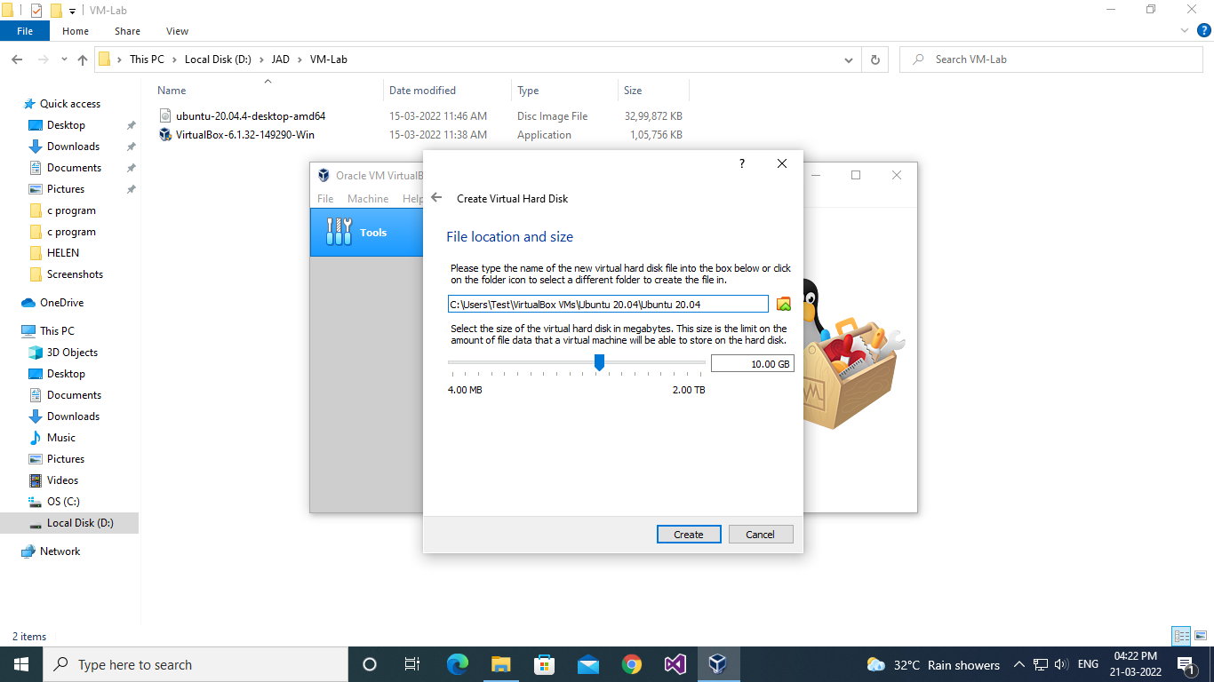

**Procedure**

* 1. The newly created OS instance and at the left side of the application.

**Output Screenshot**

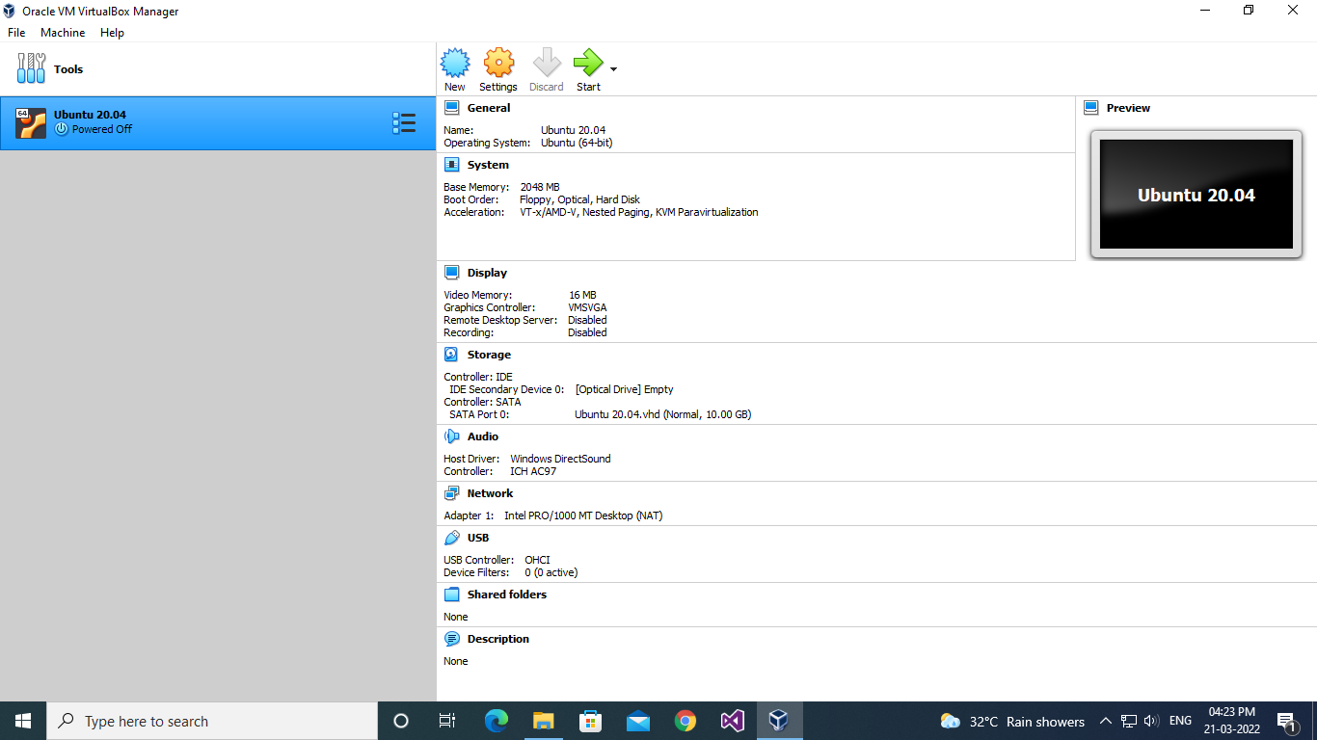

**Procedure**

* 1. Settings the configurations of the instance created and adding the ISO image file of the OS correspondingly.

**Output Screenshot**

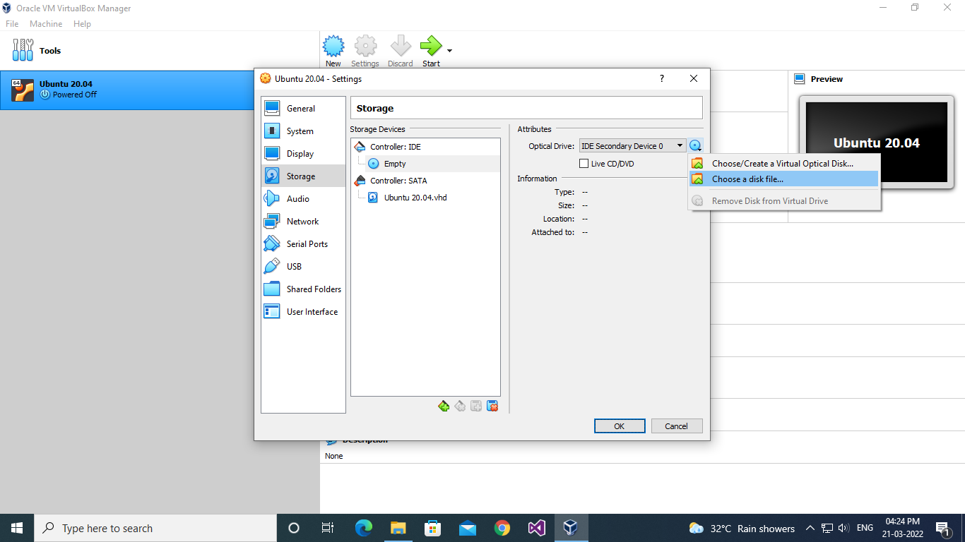

**Procedure**

* 1. Selecting the ISO image file from the local device.

**Output Screenshot**

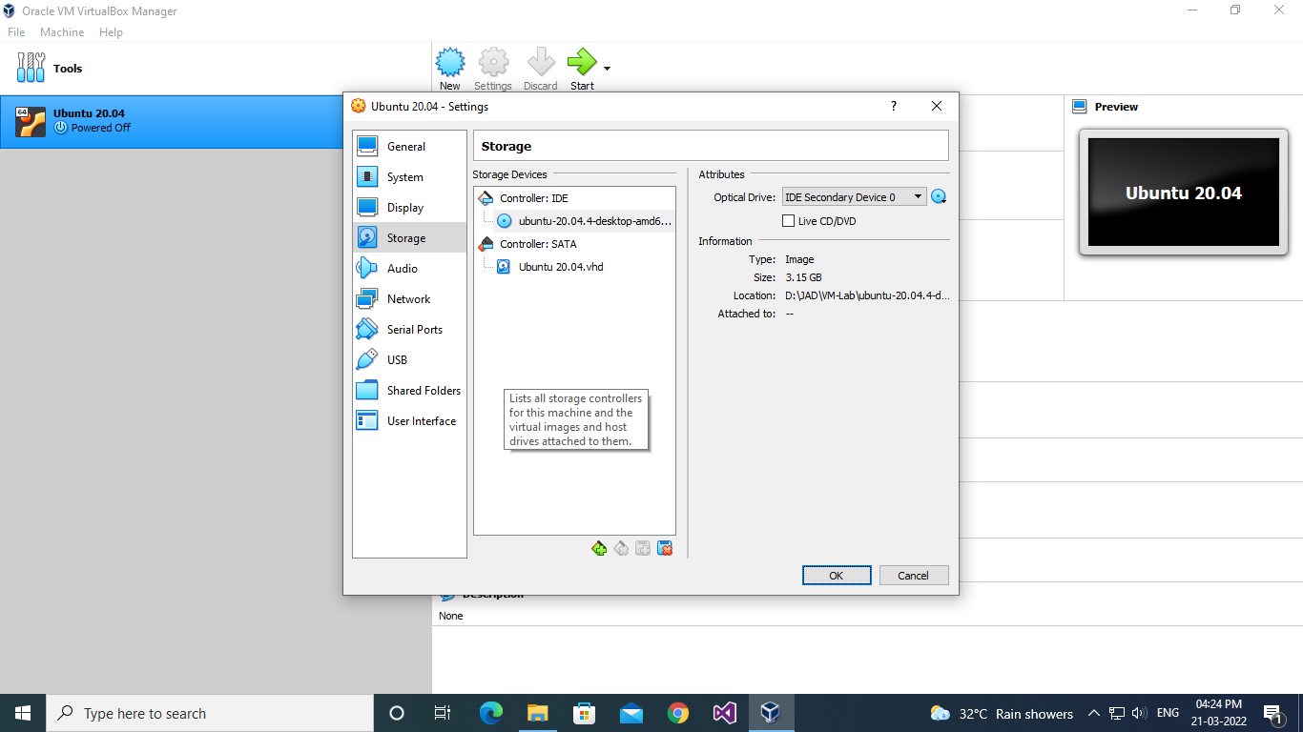

**Procedure**

1. Installation of the Ubuntu OS within the newly created instance.
   1. Running the new OS instance and selecting the “Install Ubuntu” to install the loaded ISO file.

**Output Screenshot**

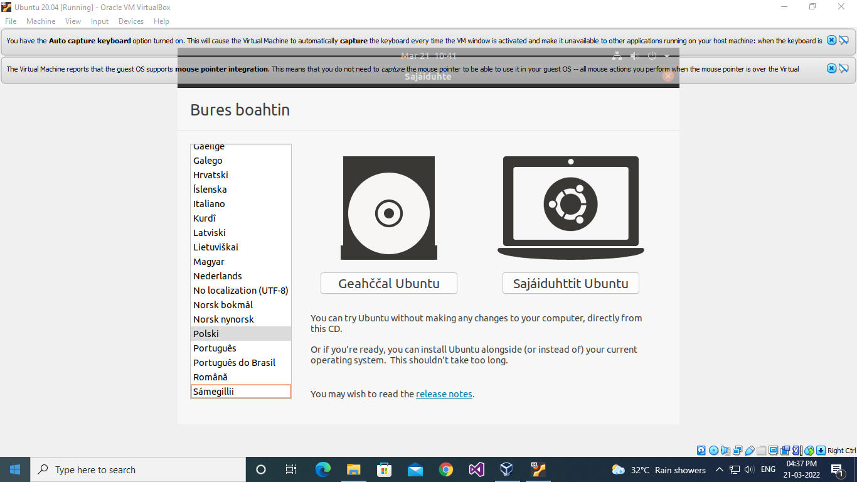

**Procedure**

* 1. Selecting the language for install the ubuntu OS.

**Output Screenshot**

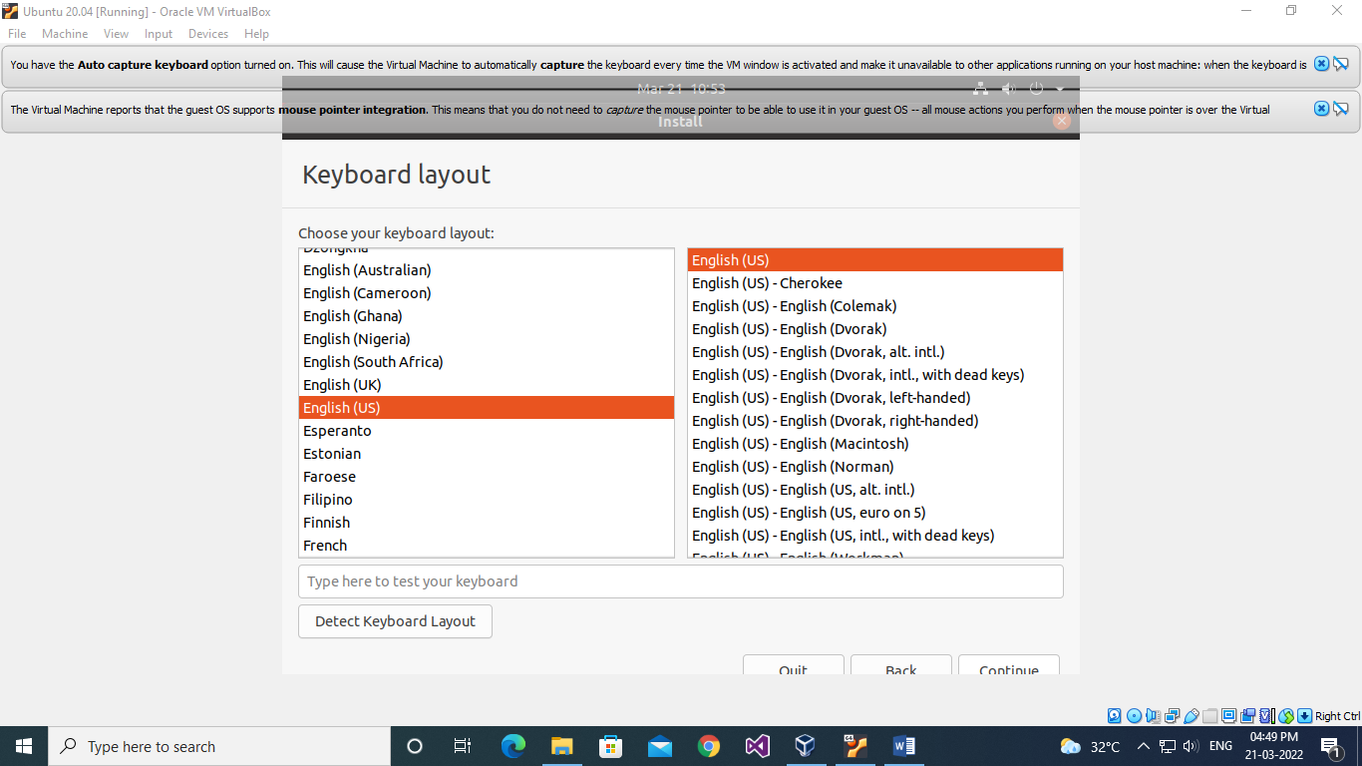

**Procedure**

* 1. Selection of other installation along & within with the installation of ubuntu.

**Output Screenshot**

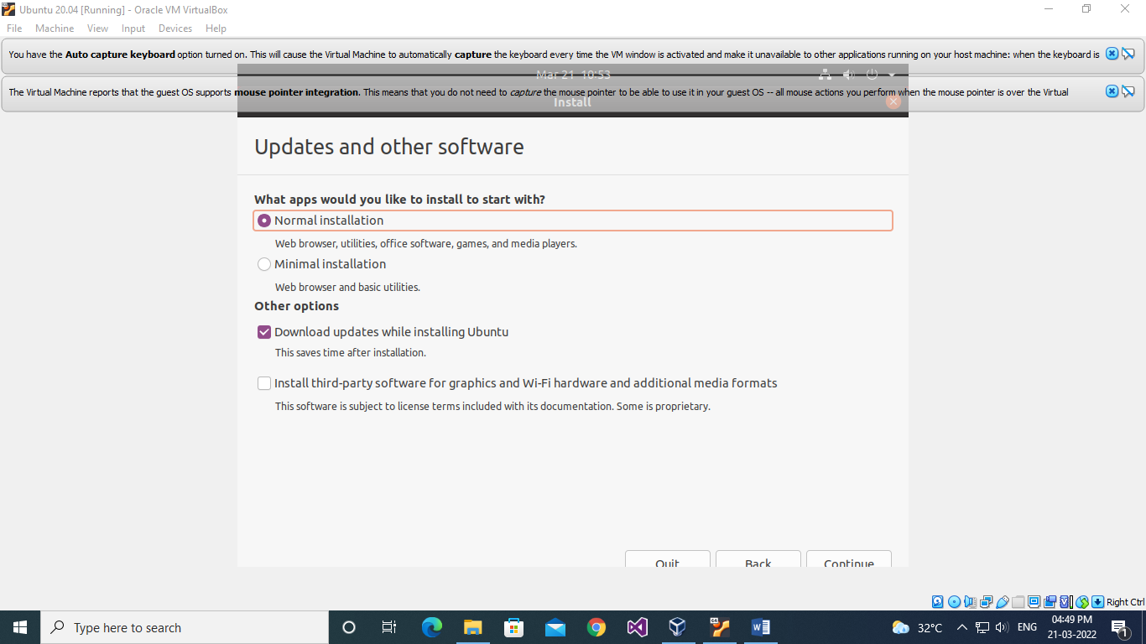

**Procedure**

* 1. Selecting the disk partitioning allocation options from the given below.

**Output Screenshot**

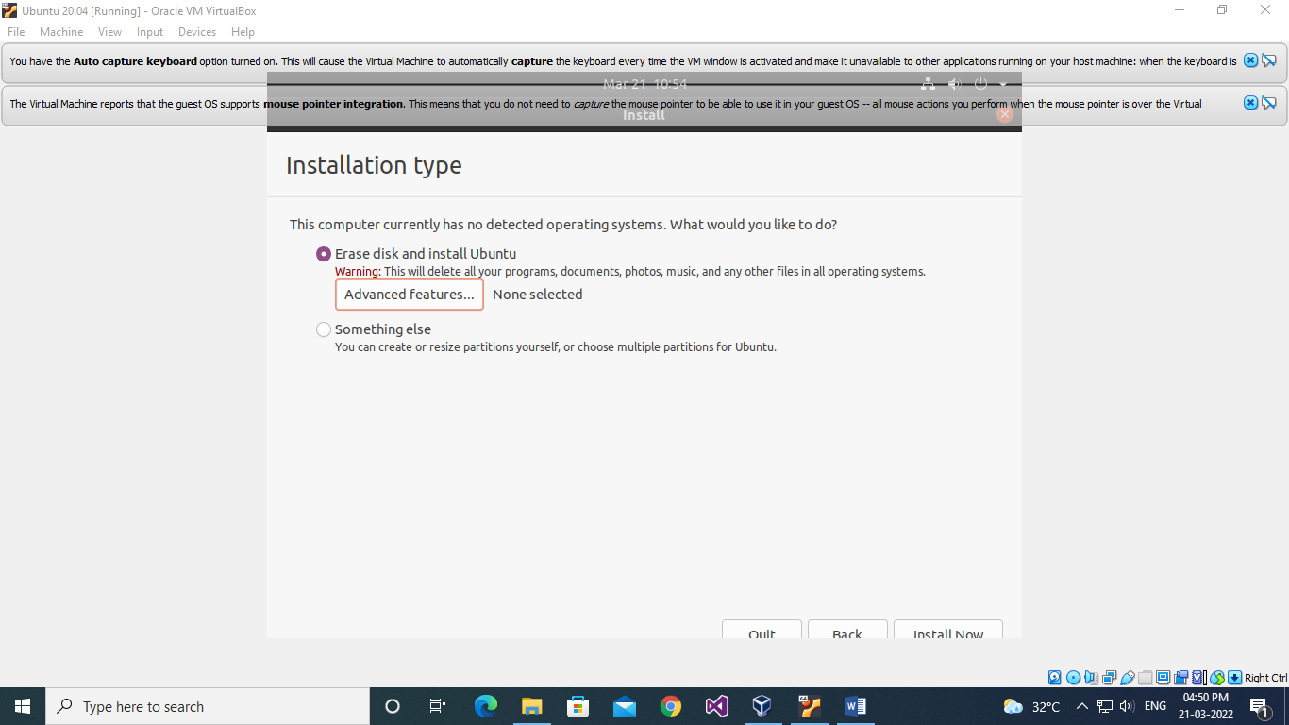

**Procedure**

* 1. Warning message box about the formatting and partitioning of the allotted hard disk.

**Output Screenshot**

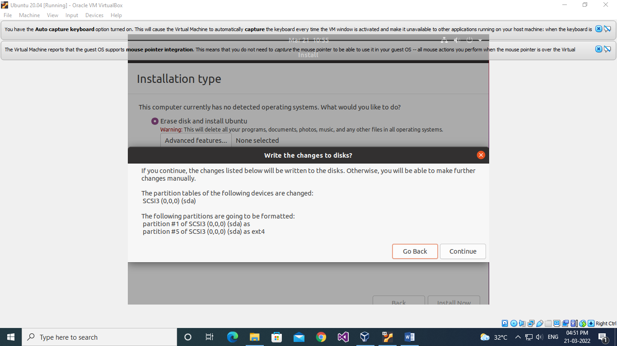

**Procedure**

* 1. Selecting the geographical location for the time/location.

**Output Screenshot**

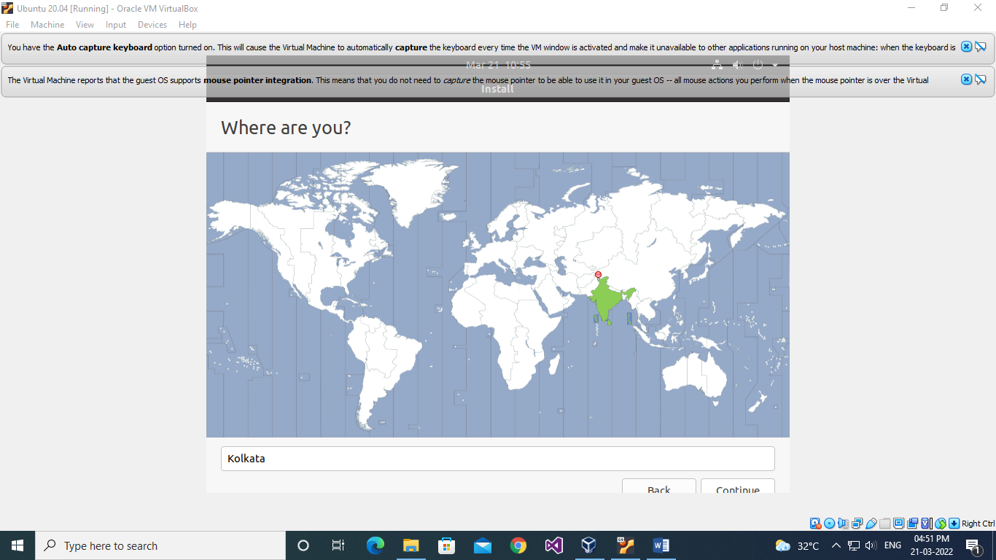

**Procedure**

* 1. Entering the name, username & password for the account to sign in to the ubuntu OS after installation.

**Output Screenshot**

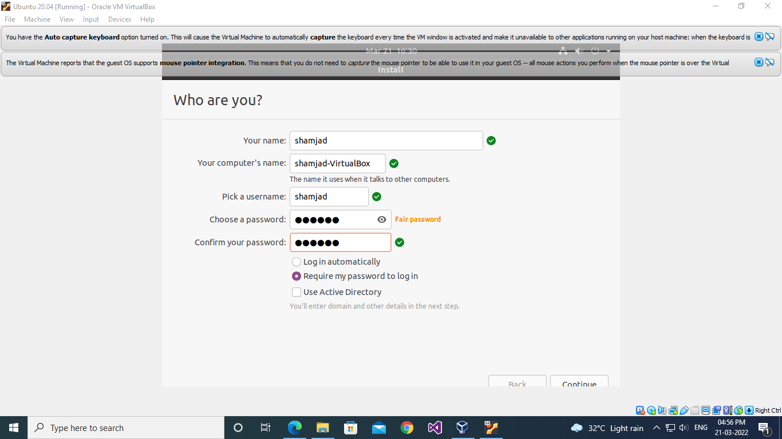

**Procedure**

* 1. Installing the ubuntu OS in the instance, extracting the ubuntu ISO file, setting configurations, setting the various software within, etc.

**Output Screenshot**

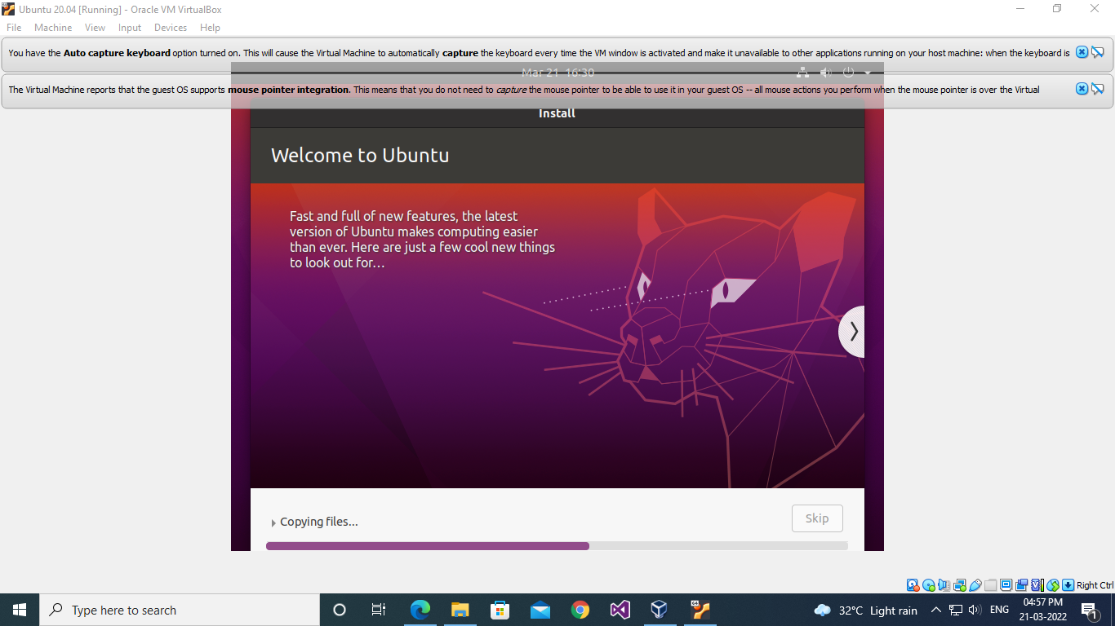

**Procedure**

* 1. Restarting the OS instance to finalize the installation.

**Output Screenshot**

**Procedure**

* 1. Signing in and visiting the home screen of the ubuntu OS using the previously registered username & password.

**Output Screenshot**

**Name: SHAMJAD MAZOOD NAZER**

**Roll No: 36**

**Batch: R-MCA B**

**Date: 21/03/2022**

**NETWORKING & SYSTEM ADMINISTRATION LAB**

**Experiment No.: 2**

**Aim**

.

**Procedure**

**Output Screenshot**

**Name: SHAMJAD MAZOOD NAZER**

**Roll No: 36**

**Batch: R-MCA B**

**Date: 21/03/2022**

**NETWORKING & SYSTEM ADMINISTRATION LAB**

**Experiment No.: 3**

**Aim**

.

**Procedure**

**Output Screenshot**